**Write Your Name: ………………………………….**

|  |  |  |
| --- | --- | --- |
| Question | Mark |  |
| Q1 |  |  |
| Q2 |  |  |
| Q3 |  |  |
| Q4 |  |  |
| Q5 |  |  |
| Total |  | 100 |

………………………………………………………………………………………………………………………

1. Answer the below questions
2. Router A has the following RIP routing table. What would be the table's contents if the router received the following RIP message from router C? (Hint: ﻿assume that router C is one hop away)

|  |  |  |
| --- | --- | --- |
| Net1 | 4 | B |
| Net2 | 2 | C |
| Net3 | 1 | F |
| Net4 | 5 | G |

|  |  |
| --- | --- |
| Net1 | 2 |
| Net2 | 1 |
| Net3 | 3 |
| Net4 | 7 |

**Solution**

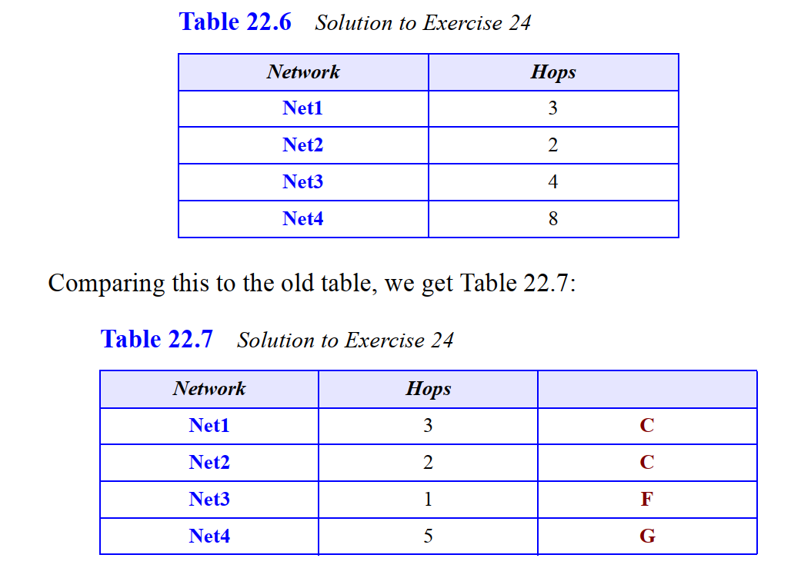

1. Suppose we have a network in which all links cost 1. Give the smallest network consistent with these two forwarding tables:

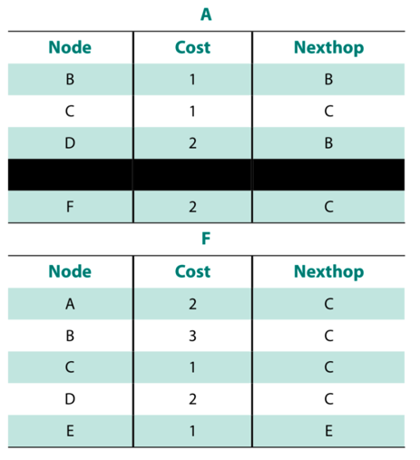

**Solution:**

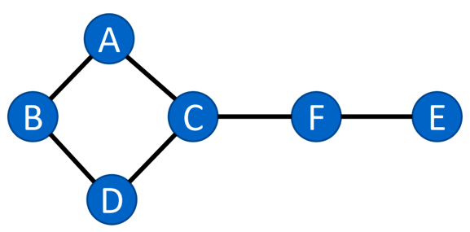

1. Consider the following networks: network I (containing nodes A, B, C) and network II (containing nodes D, E, F).

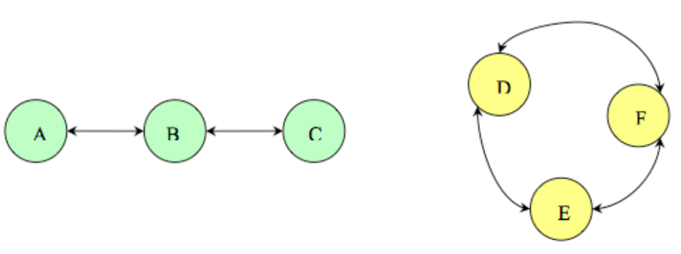

1. The Distance Vector Protocol described in class is used in both networks. Assume advertisements are sent every 5-time steps, all links are fully functional, and there is no delay in the links. Nodes take zero time to process advertisements once they receive them. The HELLO protocol runs in the background every time step in a way that any changes in link connectivity are reflected in the next DV advertisement. We count time steps from t=0-time steps. Please fill in the following table:

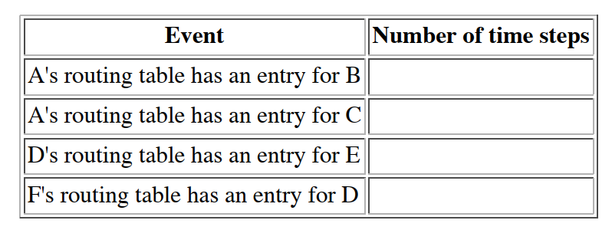

Solution

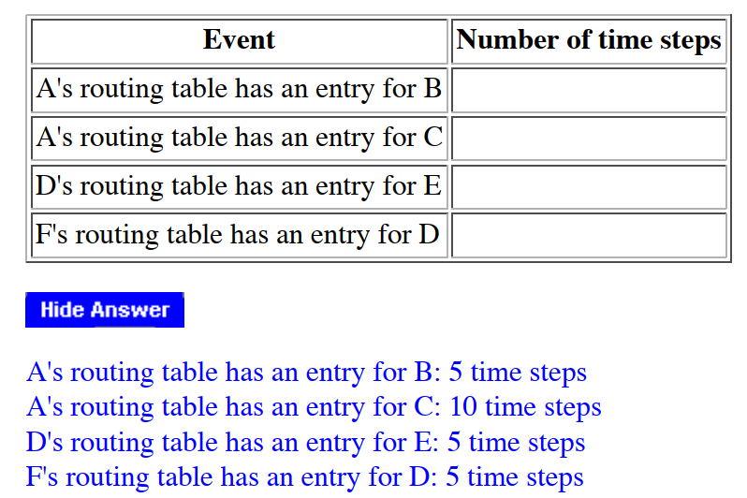

1. Now assume the link B-C fails at t = 51 and link D-E fails at t = 71-time steps. Please fill in this table:

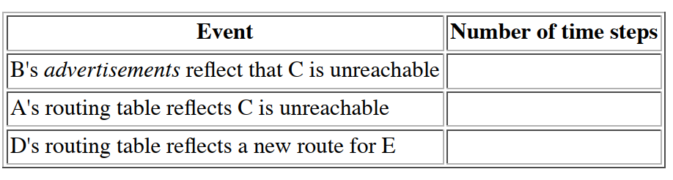

Solution

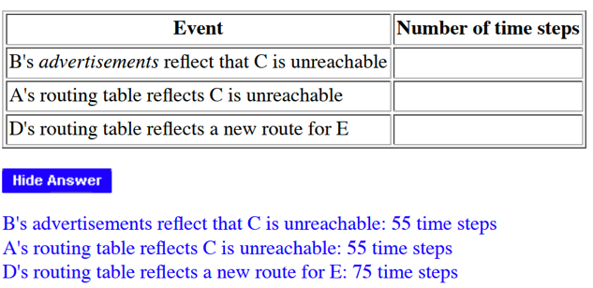

1. Consider the network shown below. The number near each link is its cost. We're interested in finding the shortest paths (taking costs into account) from S to every other node in the network. What results from running Dijkstra's shortest path algorithm on this network? To answer this question, near each node, list a pair of numbers: The first element of the pair should be the order or the iteration of the algorithm in which the node is picked. The second element of each pair should be the shortest path cost from S to that node. To help you get started, we've labelled the first couple of nodes: S has a label (Order: 0, Cost: 0), and A has a label (Order: 1, Cost: 2)

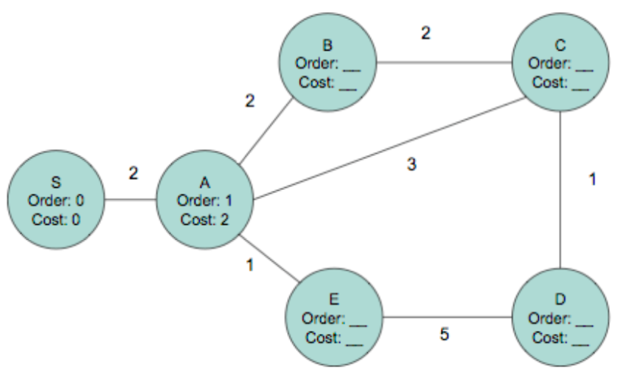

Solution

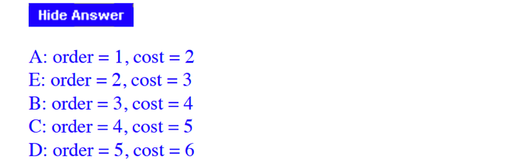

1. **Answer the below questions by choosing all the required answers [ Marks]**
2. If you are a network designer and you face the below cases, then for what case you will use static routing and what case you will use dynamic routing:
3. Security is needed **Static**
4. Your network size is fixed and there is no option to expand it **Static**
5. Your knowledge in routing is limited **Dynamic**
6. You have routers with a limited resources **Static**
7. Split-horizon states that no advertisements will be sent back through the interface on which they were received. What mechanism overrides that behavior?
8. Triggered updates
9. Hold-down timers
10. Poison reverse
11. Nothing overrides split-horizon
12. Refer to **Figure 4**. What is the cost of the route to the 10.0.0.0 network?
    * 1. 2  b. 110  c. 1786 d. 1.544

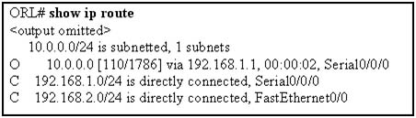

1. ﻿Which route statement must be configured on Router A to allow routing to Network B?

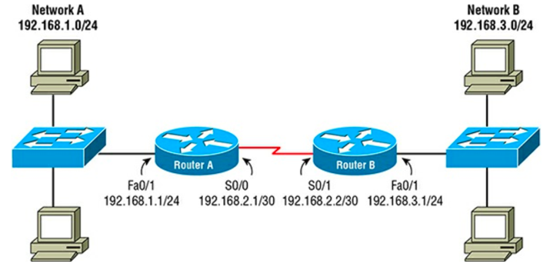

* 1. ﻿RouterA(config)#ip route 192.168.3.0 255.255.255.0 serial 0/1
  2. RouterA(config)#ip route 192.168.3.0 255.255.255.0 192.168.2.1
  3. RouterA(config)#ip route 192.168.3.0 255.255.255.0 192.168.2.2
  4. RouterA(config)#ip route 192.168.3.0 255.255.255.0 192.168.3.1

1. Which command will display all the EIGRP feasible successor routes known to a router?
   1. *show ip routes*
   2. *show ip eigrp summary*
   3. *show ip eigrp topology*
   4. *show ip eigrp adjacencies*
2. You get a call from a network administrator who tells you that he typed the following into his router:

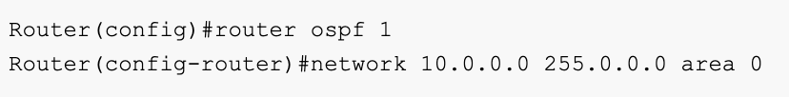

1. The wildcard mask is incorrect.
2. The OSPF Process ID is incorrect.
3. The command is wrong.
4. The AS configuration is wrong.
5. Referring to the exhibit, when running EIGRP, what is required for R1 to exchange routing updates with R3?

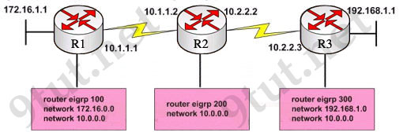

* 1. AS numbers must be changed to match all the routers
  2. Loopback interfaces must be configured, so a DR is elected
  3. he no auto-summary command is needed on R1 and R3
  4. R2 needs to have two network statements, one for each connected network

1. Refer to the exhibit. Given the output from the show ip eigrp topology command, which router is the feasible successor?

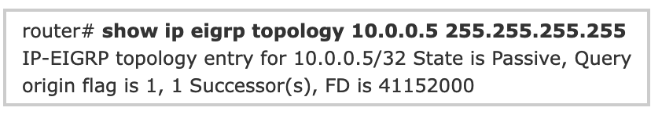

|  |  |
| --- | --- |
| 1. 10.1.0.1 (Serial0), from 10.1.0.1, Send flag is 0×0 Composite metric is (46152000/41640000), Route is Internal  Vector metric: Minimum bandwidth is 64 Kbit  Total delay is 45000 Microseconds  Reliability is 255/255  Load is 1/255  Minimum MTU is 1500  Hop count is 2 | 1. 10.0.0.2 (Serial0.1), from 10.0.0.2, Send flag is 0×0 Composite metric is (53973248/128256), Route is Internal  Vector Metric: Minimum bandwidth is 48 Kbit  Total delay is 25000 Microseconds  Reliability is 255/255  Load is 1/255  Minimum MTU is 1500  Hop count is 1 |
| 1. 10.1.0.3 (Serial0), from 10.1.0.3, Send flag is 0×0 Composite metric is (46866176/46354176), Route is Internal  Vector metric: Minimum bandwidth is 56 Kbit Total delay is 45000 microseconds Reliability is 255/255 Load is 1/255 Minimum MTU is 1500 Hop count is 2 | 1. 10.1.1.1 (Serial0.1), from 10.1.1.1, Send flag is 0×0 Composite metric is (46763776/46251776), Route is External  Vector metric: Minimum bandwidth is 56 Kbit Total delay is 41000 microseconds Reliability is 255/255 Load is 1/255 Minimum MTU is 1500 Hop count is 2 |

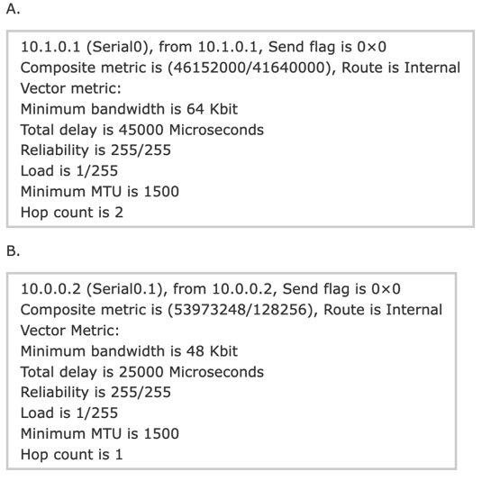 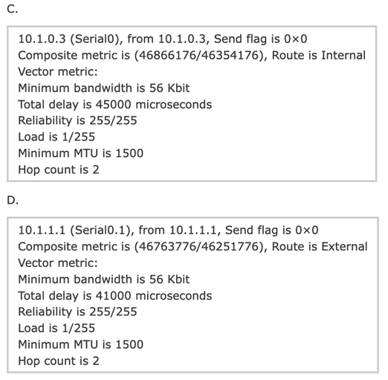

1. Refer to the exhibit. How many paths can the EIGRP routing process use to forward packets from HQ_Router to a neighbor router?

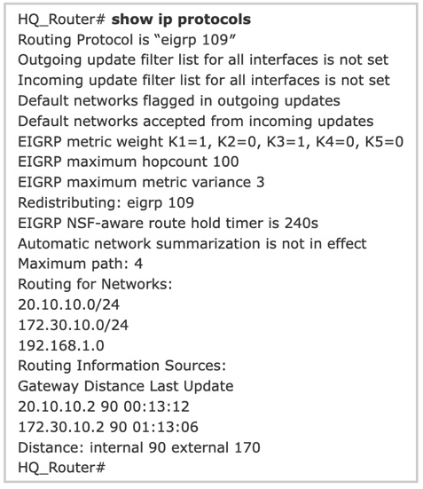

* + - 1. two equal-cost paths  
         B. two unequal-cost paths  
         C. three equal-cost paths  
         D. three unequal-cost paths  
         E. four equal-cost paths  
         F. four unequal-cost paths

1. IP address and routing for the network are configured as shown in the exhibit. The network administrator issues the show ip eigrp neighbors command from Router1 and receives the output shown below the topology. Which statement is true?

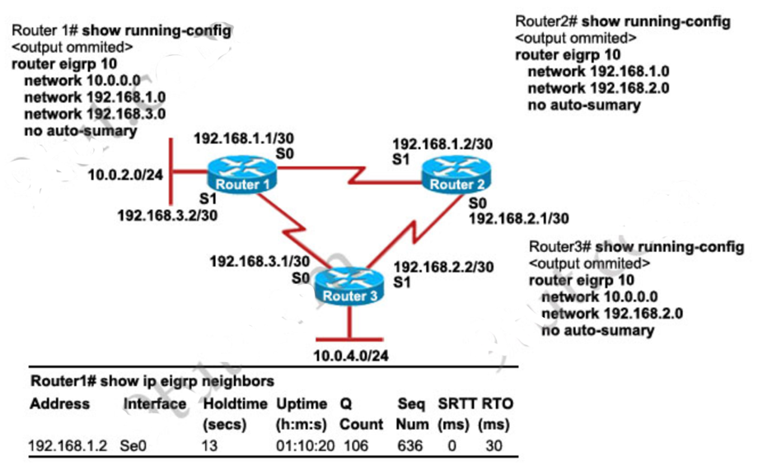

* + - 1. It is normal for Router1 to show one active neighbor at a time to prevent routing loops.  
         B. Routing is not completely configured on Router3.  
         C. The IP addresses are not configured properly on the Router1 and Router3 interfaces.  
         D. The no auto-summary command configured on the routers prevents Router1 and Router2 from forming a neighbor relationship.

1. A network administrator is troubleshooting the OSPF configuration of routers R1 and R2. The routers cannot establish an adjacency relationship on their common Ethernet link. The graphic shows the output of the show ip ospf interface e0 command for routers R1 and R2. Based on the information in the graphic, what is the cause of this problem?

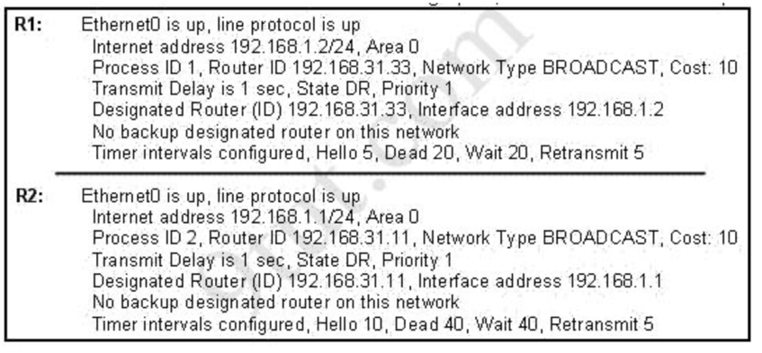

* + - 1. The OSPF area is not configured properly.  
         B. The priority on R1 should be set higher.  
         C. The cost on R1 should be set higher.  
         D. The hello and dead timers are not configured properly.  
         E. A backup designated router needs to be added to the network.  
         F. The OSPF process ID numbers must match.

1. **Refer to the exhibit. Considering that R2, R3, and R4 are correctly configured, why did R1 not establish an adjacency with R2, R3, and R4?**

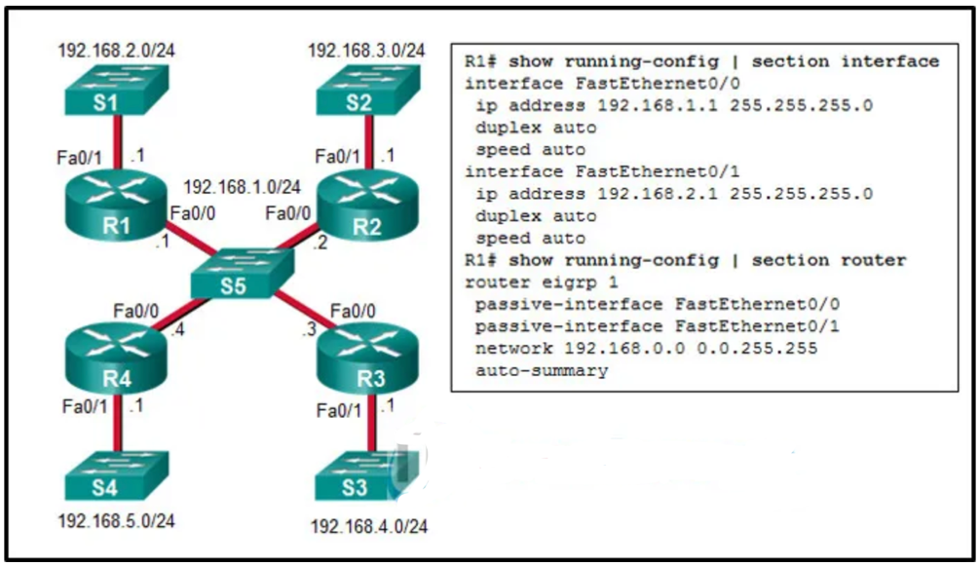

* **because the Fa0/0 interface of R1 is declared as passive for EIGRP**
* because the automatic summarization is enabled on R1
* because the IPv4 address on Fa0/0 interface of R1 is incorrect
* because there is no network command for the network 192.168.1.0/24 on R1

1. The topology below is running EIGRP. You are required to troubleshoot and resolve the EIGRP issues between the various routers. Use the appropriate show commands to troubleshoot the issues.

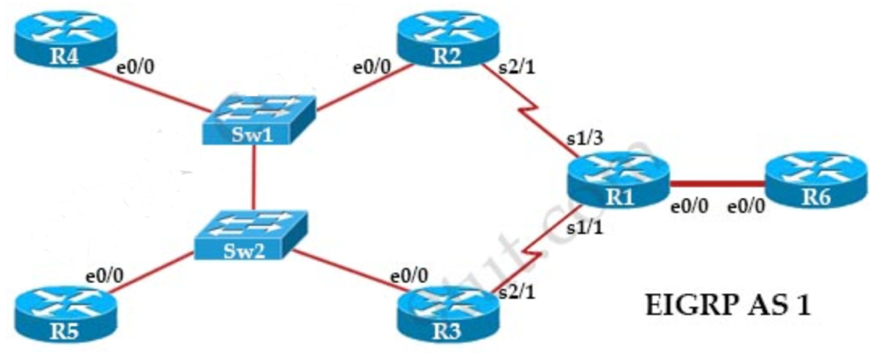

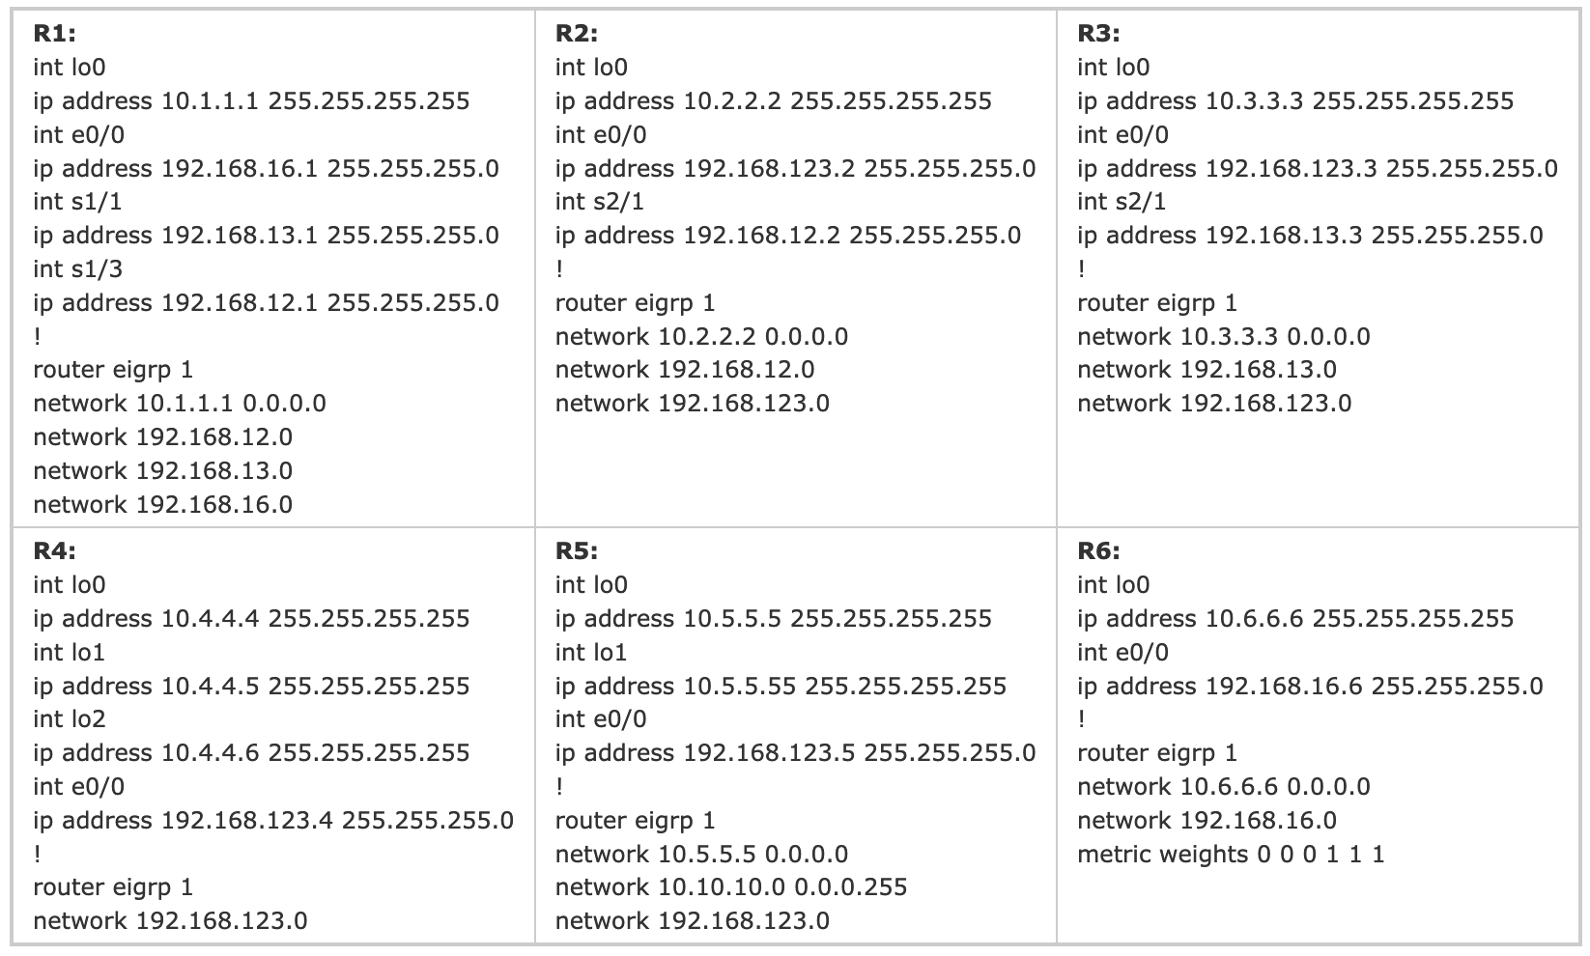

Solution: We can see R4 is missing the “network 10.4.4.4 0.0.0.0”, “network 10.4.4.5 0.0.0.0” and “network 10.4.4.6 0.0.0.0” statements so R5 cannot learn them.

1. Configure the below network with OSPF routing protocol

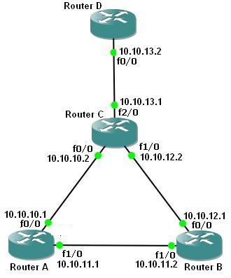

RouterA# router ospf 1

RouterA# **network 10.10.10.0 0.0.0.255 area 0**

RouterA# **network 10.10.11.0 0.0.0.255 area 0**

B(config)# **router ospf 1**  
B(config-router)# **network 10.10.11.0 0.0.0.255 area 0**  
B(config-router)# **network 10.10.12.0 0.0.0.255 area 0**

C(config)# **router ospf 1**  
C(config-router)# **network 10.10.10.0 0.0.0.255 area 0**  
C(config-router)# **network 10.10.12.0 0.0.0.255 area 0**  
C(config-router)# **network 10.10.13.0 0.0.0.255 area 0**